**2021 past paper**

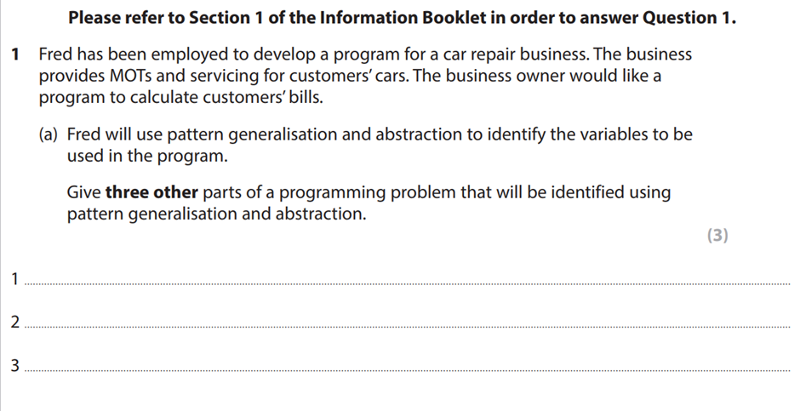

Loops

Subroutines

Input / output

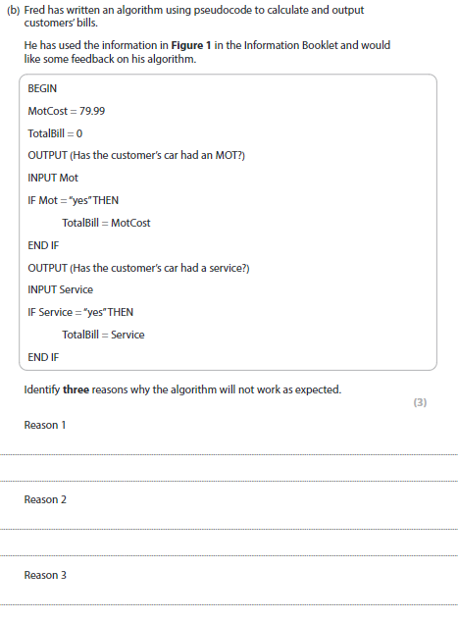

* No calculation for discount.
* The total bill does not have an output.
* There is no “ELSE” only yes for if statement.

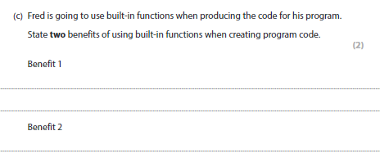

* Code is clearer to read with less errors.
* Will be much quicker.

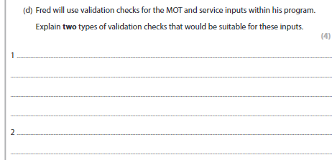

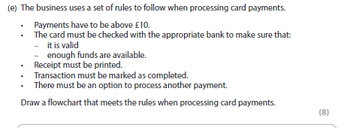

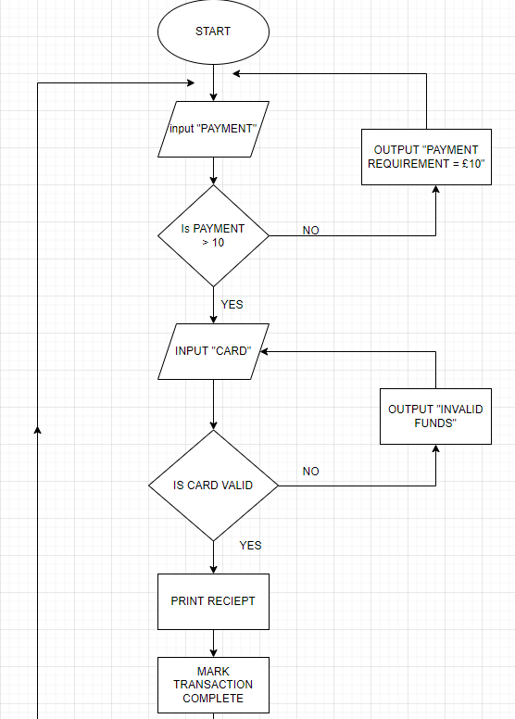

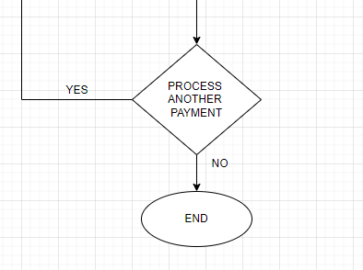

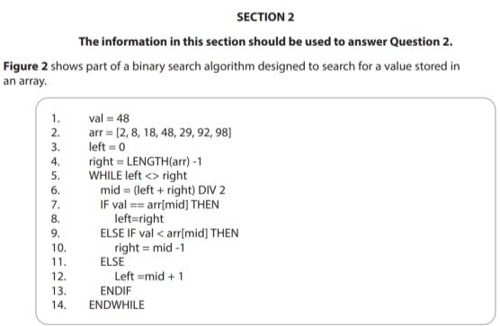

If val == ‘[Len]arr4’ THEN

OUTPUT (“Value is found”)

Elif val != ‘[Len]arr4’ THEN

OUTPUT (“Value not found”)

ENDIF

3a)

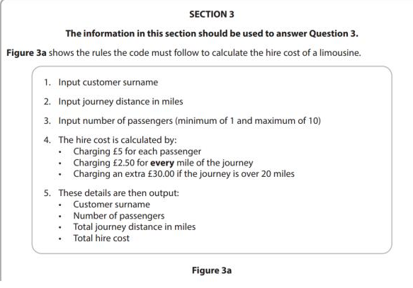

Surname = input (“Enter your name”)

JourneyDistance = int (input (“Enter the miles of your journey”)

Passengers = int (input (“Enter passengers from 1-10)

WHILE passengers < ‘1’ OR > ‘10’ THEN

OUTPUT (“please enter between 1 to 10 passengers”)

Passengers = USERINPUT

OUTPUT (“you have” + passengers + “passengers”)

ENDWHILE

Fare = passengers * £5

Fare = Fare + JourneyDistance * £2.50

IF JourneyDistance > 20 THEN

TotalJourney = TotalJourney + £30

Else

OUTPUT(“you don’t have to pay an extra fee for your journey”)

ENDIF

OUTPUT (Surname)

OUTPUT (“You have” + passengers + “passengers”)

OUTPUT (“Your total journey distance cost: ” + TotalJourney )

OUTPUT (Fare)

4)

**REVISE SUBJECTS**

Pseudocode

Flowchart

Abstraction

Decomposition

Pattern generalization

Built in functions

Data validations

Binary search

Subroutines

Variables

Object orientated

Event Driven